1. Let’s see how to create validation and add this after creating collection.
2. Let’s now play around with the additional settings we can set which I already shown on my slides.
3. We want to make some more settings related to validation but the problem is that we have already validation turn on. So how to add new configuration to that?
4. 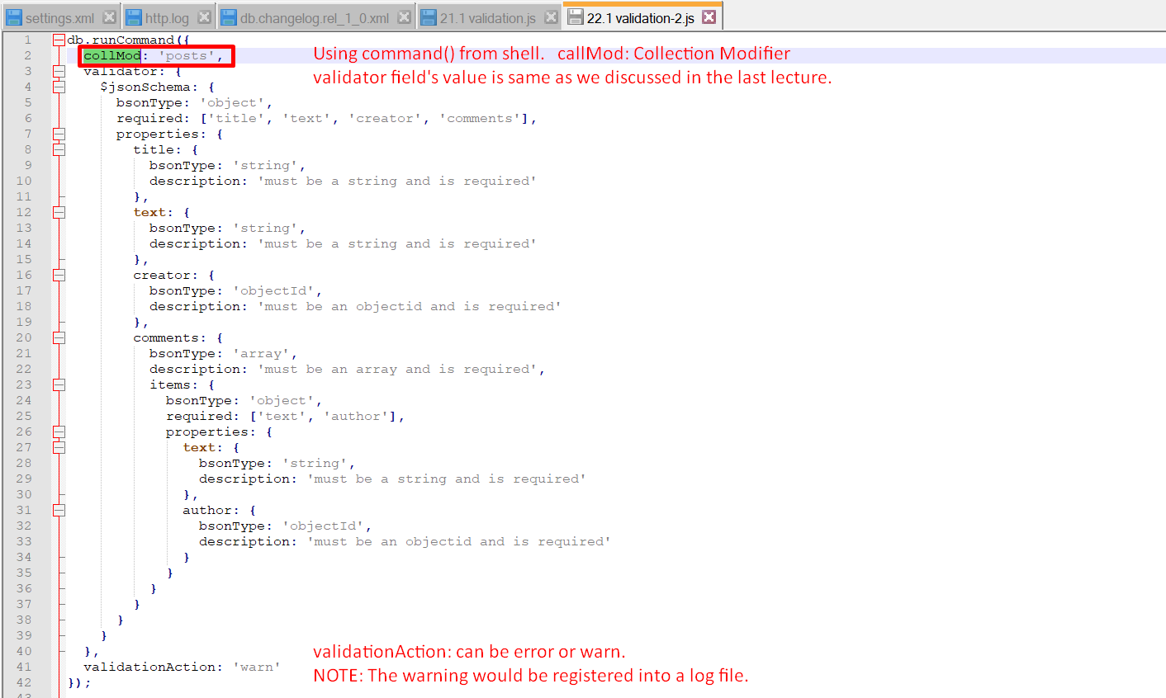
5. So, you can create the validation when
   1. Creating collection
   2. After collection has been created using the db.runCommand();